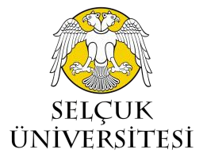
- T.C.
SELÇUK ÜNİVERSİTESİ
SAĞLIK BİLİMLERİ ENSTİTÜSÜ MÜDÜRLÜĞÜ
To Be Completed By The Teaching Staff
Branch
cvzxdfdfvcxdfdsf
Programme Type |  | Course Name |  |  |  | Semester |  | Credits
☐ Master  ☐ Doctorate |  |  |  |  |  | ☐ Autumn  ☐ Spring |  | T | L |  |  |  | ECTS
Instructor |  |  |  |  | Language |  |  | Course Status
 |  |  |  |  | ☐ Turkish  ☐ English  ☐ Other……………….. |  |  | Required |  |  |  | Elective
Methods of Assessment
 | Exams and Assessment Methods |  |  |  |  |  | Number |  |  |  | Percentage (%)
 | Laboratory
 | Oral exam
 | Homework +Oral exam
 | Project + Oral exam
 | Written exam
 | Other (……………….)
Course Objectives
Course Description |  |  |  | 1-  2-  3-  4-  5-  6-  7-  8-  9-  10-  11-  12-  13-  14-
Course Outcomes
Teaching Method
References
Course Category by Contet (%) |  |  |  | Health Science |  |  |  |  |  | %
 |  |  |  |  |  |  |  |  |  | %
 |  |  |  |  |  |  |  |  |  | %
 |  |  |  |  |  |  |  |  |  | %
T: Theory L: Laboratory ECTS: European Credit Transfer System
Sağlık Bilimleri Enstitüsü Müdürlüğü  Konya / TÜRKİYE | E – Posta : sagbil@selcuk.edu.tr | Telefon : +90 332 2232453  Fax : +90 332 2410551

